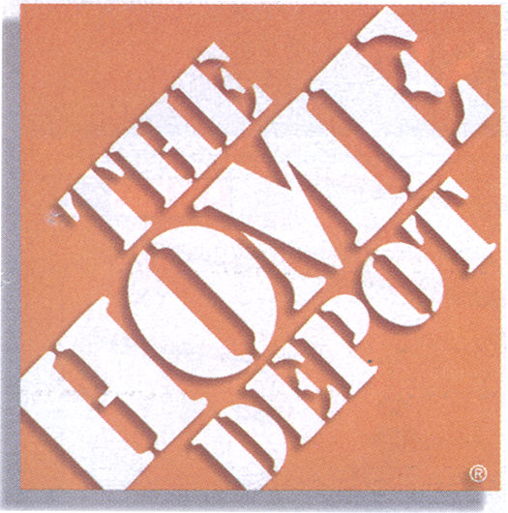

Non Compliance / Watering

Store #: ________________________

Location: _______________________

Date: __________________________

□ This store does not employ a designated full time waterer.
□ Not watering plants in need, thus creating unnecessary plant loss.

I understand by not being in compliance my DM and THD merchant will be informed. I also understand that by continued non compliance, I run the risk of not being in supply of any and all live goods until I can be in complete compliance.

Store Managers Name ______________________________________
(Please Print)

Store Managers Signature ____________________________________

Comments:______________________________________________________________________________________________________________________________________________________________________________________________________________________________________________________________________________________________________________________________________________________________

cc: Chris Hopkins
District Manager

